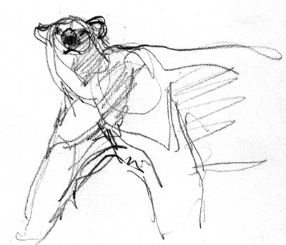
BIOLOGY SYLLABUS

Welcome to Biology! I would like to share some important information so that this will be a positive year for everyone.

Teacher: Mrs. Jackson, email: kristinejackson@hasd.org 779-7933 ext. 15111

Course Description: Biology is a High School level course designed to increase your knowledge of scientific topics related to the study of living things. After all, Biology literally means “the study of life”! We will be building on topics that you have already covered in middle school. This year you will also gain or improve on valuable life skills such as: questioning what you see, technological know-how, citizen action and problem solving. Science is an incredible avenue for these types of exploration. I am committed to your education and I love my job.
NOTE: This class counts as a life science class required for graduation.

Textbooks: Holt Biology by Johnson and Raven and various online and printed
materials to be distributed as the course progresses

Materials: You must bring these things with you everyday!
- 3 ring binder
- 1-subject notebook/loose-leaf paper
- Pencil
- Student passbook
Useful but not required: calculator, colored pencils

Online Resources: We will be using Canvas to integrate your learning experience this year in Biology. Please use this as a guide to help you study, find extended learning opportunities, and a place to learn when you are not able to attend class. You will find videos, lecture notes, and lab information to assist you with your learning.

Access to Canvas: Log onto Canvas from the hasd.org website,search Jackson, click on Canvas -sign in. Your username is firstlast@hasd.org and your password is the same as logging onto the school computer.

Behaviors:
I am giving you the benefit of the doubt. I think you are going to like it here and want to participate. I also believe that every student can give frequent, meaningful and constructive contributions. Here are some examples of what I consider appropriate behavior: URA Polar Bear!
- Using appropriate language and listening. Be a good listener when others are talking. Use positive language!! (no foul language, derogatory or racial comments, inappropriate or disrespectful behavior)
- Participating in labs, class activities, videos, and class discussions.
- Following lab safety rules (such as wearing goggles).
- Displaying proper use of class work time. (no texting or using phones unless asked to do so. If I see your phone…I will collect it.)
- Working in a group setting.
- Cleaning your lab station and glassware. All materials should be cleaned and returned to the original set up.
- Staying in seat until excused. (No “lining up” by the door.)
- Do your own work: cheating will not be tolerated and will result in a major referral. In addition, parents and admisistration will be informed. (THIS INCLUDES COPYING SOMEOME ELSE’S WORK AND PLAGIARISM.) Any student involved will need to re-submit evidence of learning as approved by your teacher.

Labs:
Laboratory policy: INAPPROPRIATE BEHAVIOR IN THE LABORATORY IS VERY DANGEROUS. IF THIS HAPPENS, NO WARNINGS WILL BE GIVEN. YOU WILL BE ASKED TO SIT DOWN AND FURTHER DISCIPLINARY ACTION WILL BE TAKEN AS NECESSARY. THIS IS A ZERO TOLERANCE ZONE.
- You will be assigned lab groups.

Attendance:
Attending class is vital to your success. Be here every day! If you know you will be absent, make plans and inform me ahead of time. This is important!! If you are going to miss class due to athletics, a field trip for another class, a guest speaker, Be Prepared and Be Responsible!

Make-Up Work:
If you are absent when assignments are due, when lab activities are done, or when quizzes or exams are given, you will be expected to complete this work the day you return to school. See your teacher for assignments you have missed. Sometimes alternate assignments will be given in place of labs, videos, or other hard to make up assignments.

Behavioral Standards: We will be focusing on the following behavioral standards this year in biology:
UNITED: A. S1: Students will communicate and collaborate with others to accomplish tasks and develop solutions to problems and opportunities.
A.S1.a. Learning Target: I can effectively work collaboratively with others.

RESPECTFUL: B. S1: Students will identify and apply employability skills.
B.S1.a. Learning Target: I can identify and demonstrate positive work behaviors and personal qualities needed to be employable.

ACCOUNTABLE: C. S1: Students will formulate and defend judgements and decisions by employing critical thinking
C.S1.a. Learning Target: I can defend an idea, judgement, or argument with evidence and rationale.
Standards Based Grading: .
The 4 point scale is shown below: See initial SBG letter sent to you via Skyward for more details.
Proficiency Scale Criteria for Reference
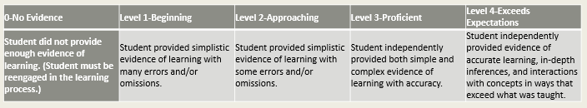

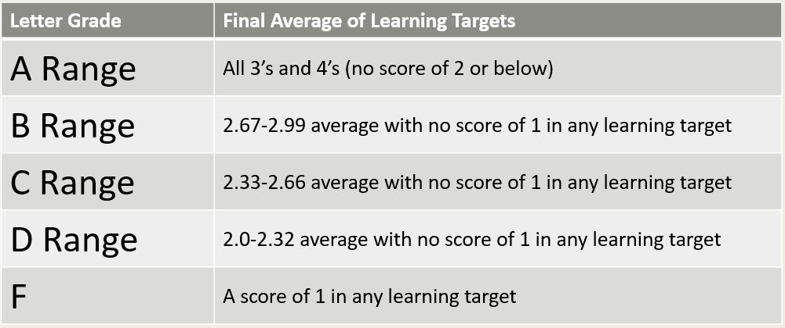
Grade Conversion Chart

* +/- determination will be based on the final exam and at teacher discretion.

Extended Learning Time (ELT): If objectives are not met each week on formative assessment quiz, then you will be selected to attend ELT for support and review. Please ask if you would like extra help!
Late Work Policy:
If any work is turned in past the due date, student is expected to talk to teacher to explain why the work was not turned in and determine the time frame and process when it will be turned in. All work that is scored must be completed to pass the class.
If a student habitually turns in assignments late, there will be a conference with student and contact with parents/guardian to bring awareness and find solution(s) to the issue.

Grade Calculation Formula – Average
- This Standards-Based Grading calculation averages all events within a learning target.
- Scores can be overridden at teacher discretion.
Retakes
Retake communication must take place with the teacher. Students may be reassessed on a portion of the assessment or the entire assessment until the end of the semester. It may be in a completely different format. Students must provide evidence that relearning has occurred by completing required formative and corrective work as determined by the teacher (i.e. retake ticket, quizlet). Retake opportunities are not available for semester exams. Retakes may not apply to long term, multistep assessments such as research papers, projects or presentations. Students will have multiple opportunities to redo portions of the project process before final submission. The final grade will be the most recent assessment per school policy. If a student is currently failing or has not submitted appropriate evidence of learning, the teacher will contact the parents upon teacher concern.

Semester Finals: This course will have a meaningful learning opportunity during the final exam period. Students are required to attend for the entire period. Finals will be utilized to determine a holistic performance of course learning targets. Performance on the final may result in a +/- at teacher discretion, or the grade may remain the same.

